1. Cleaning algorithm flowchart?

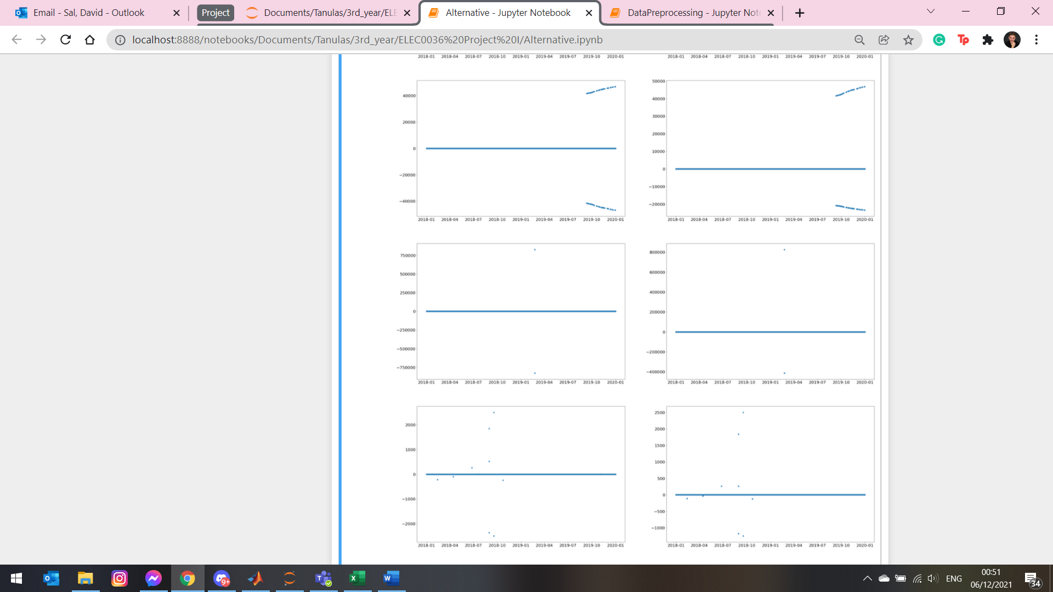

Missing parts in the algorithm?

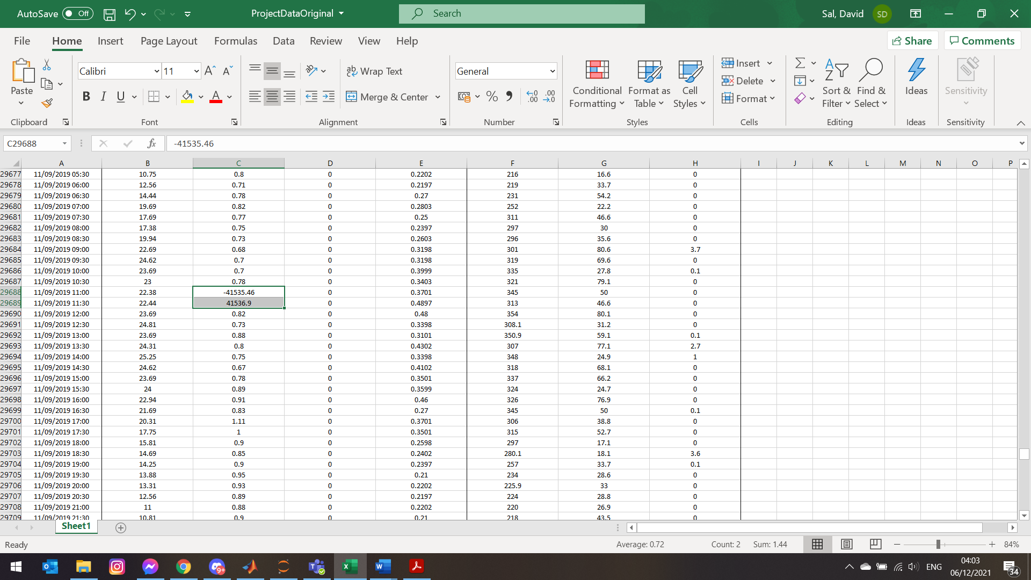

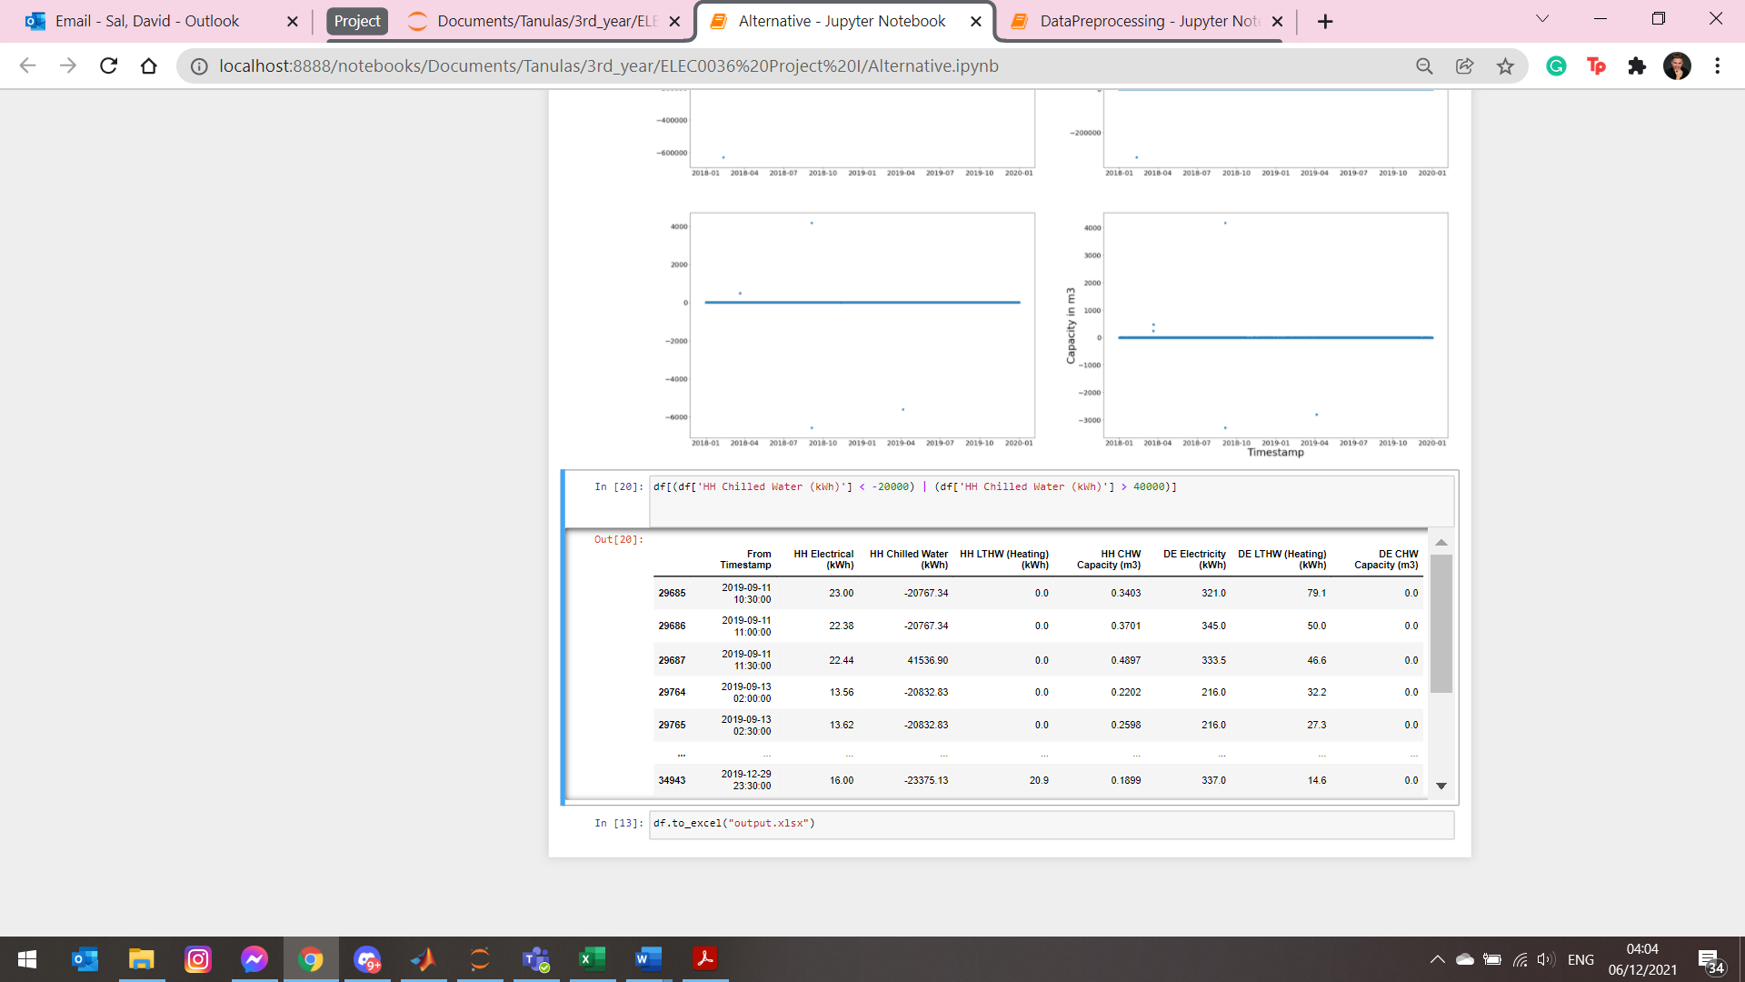

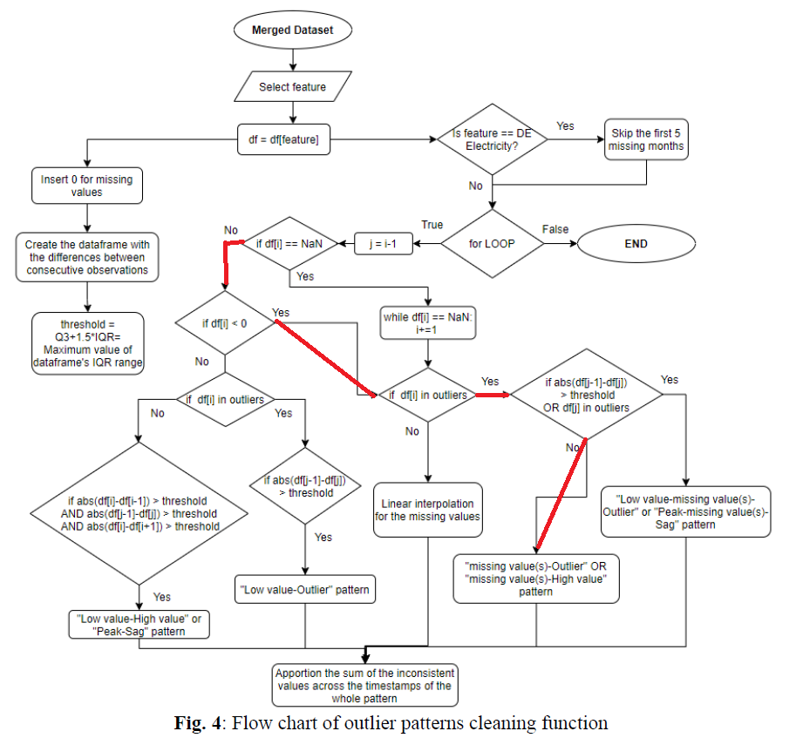

Finding connection between C degrees and Electricity

Hampel filtering methods – outlier filtering

Feature 1 Xenias algorithm works well but what happened with those ~4 points?

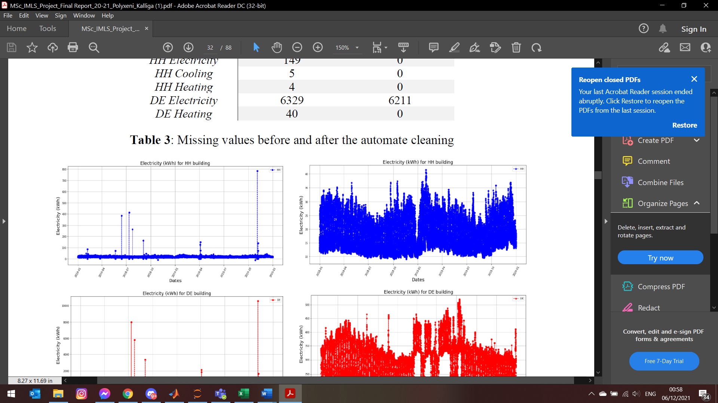

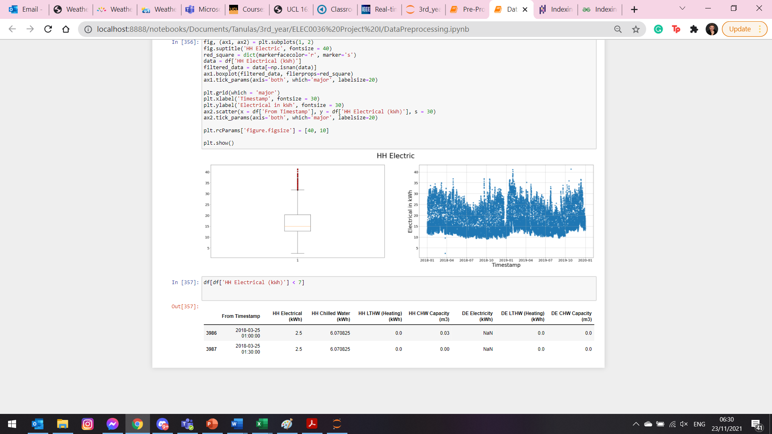

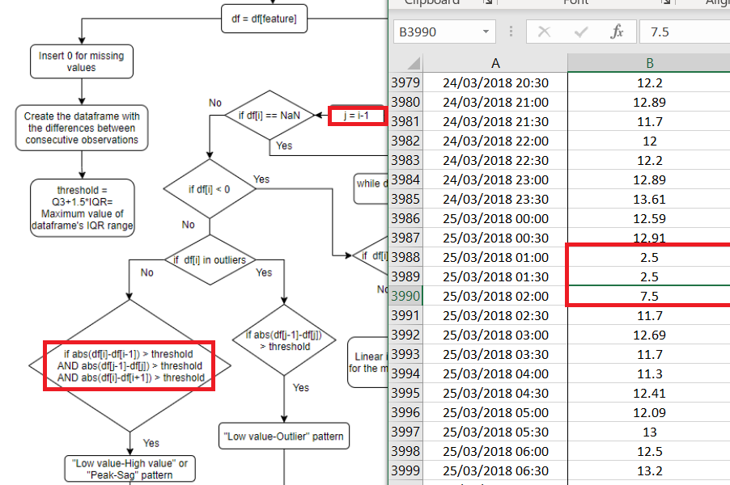

Feature 2 sag peak pattern

Feature 3 sag zeros peak

Feature 4 random large negative values such as -217.89 between 0.1 values – linear interpolation

(there is one with a NaN before the big value or even:

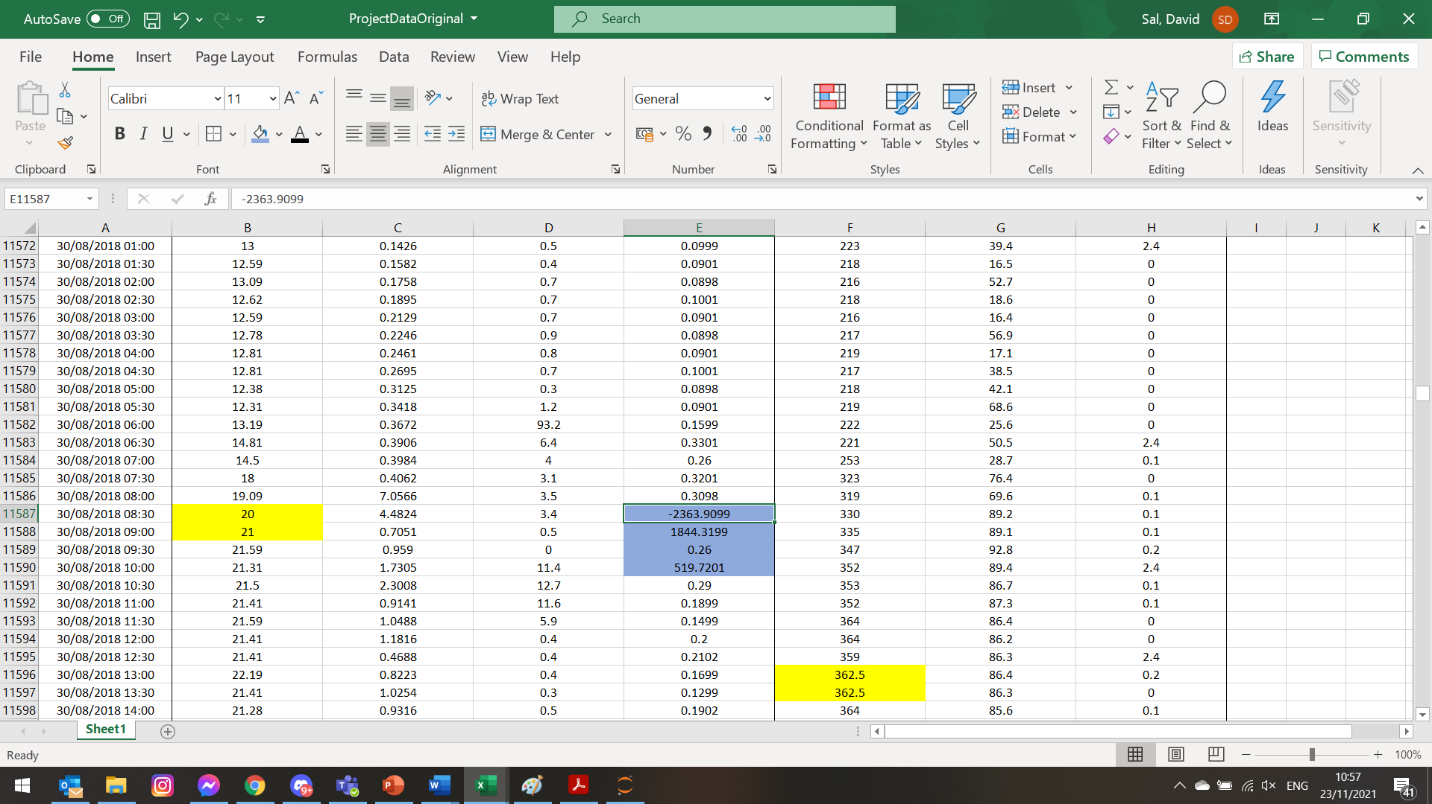

I decided to correct these manually

Feature 5 outlier negative outlier (Xenia manages negative values)

|  |  |  |
| --- | --- | --- |
| 692 |  | 649 |
| -230 |  | -217 |
| 692 |  | 654 |

Feature 6 zeros than an outlier

What to do about parts like this?

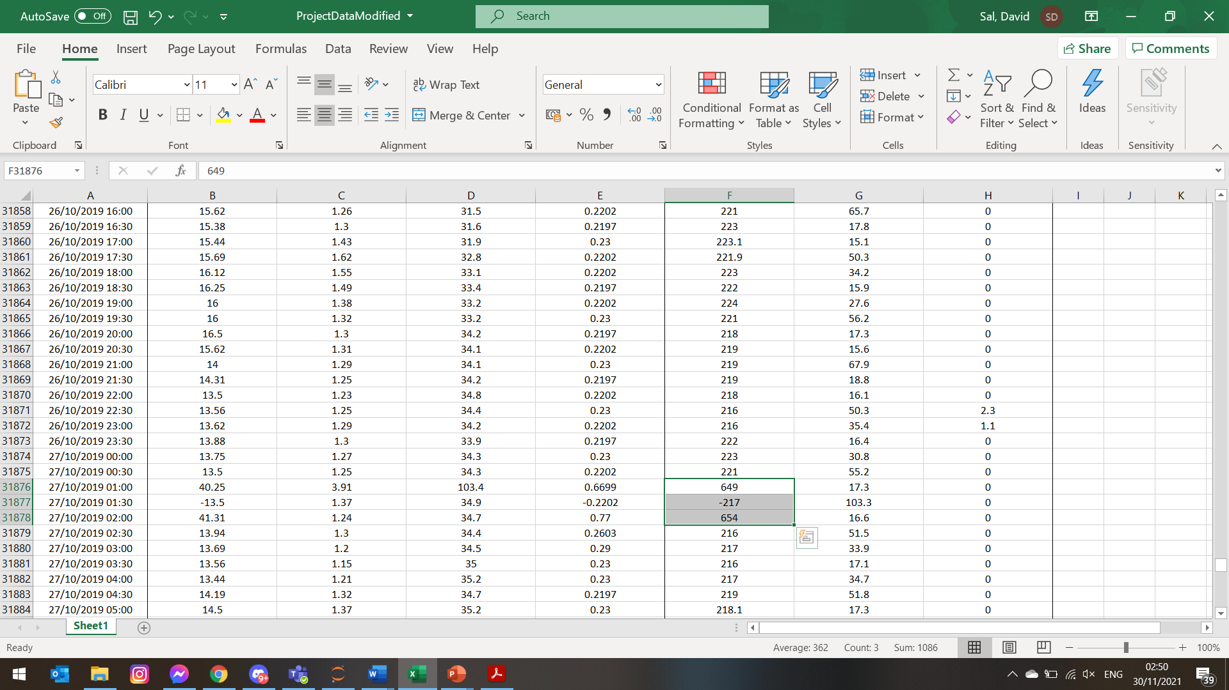

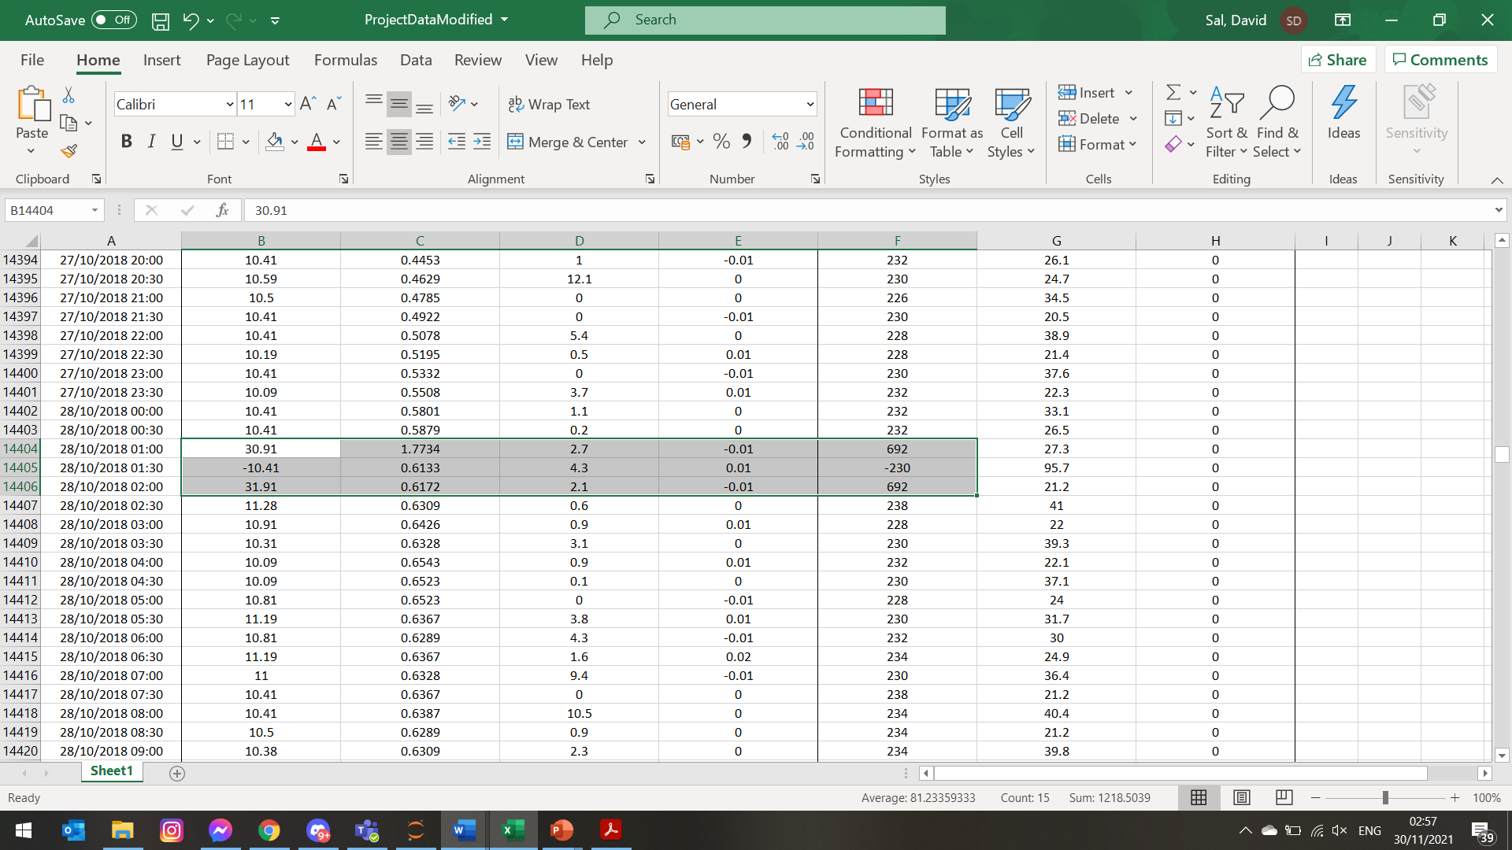

DE Heating

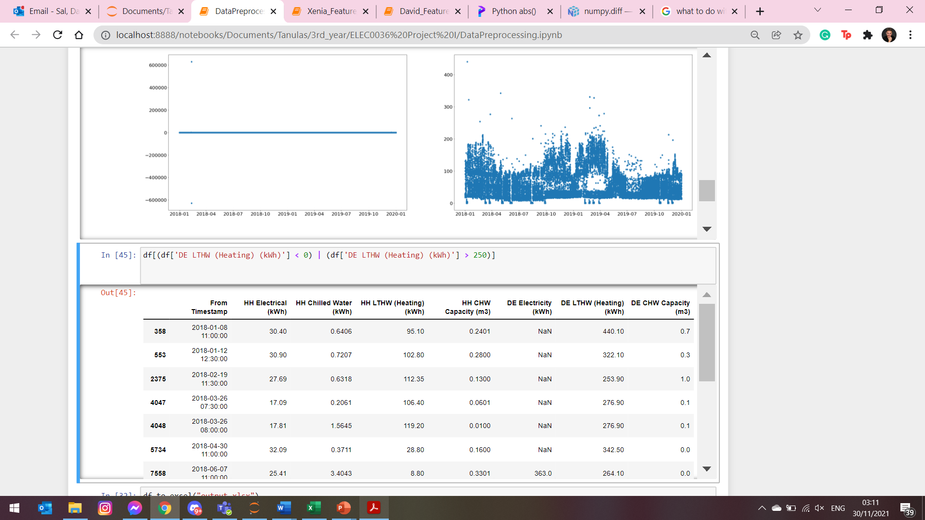

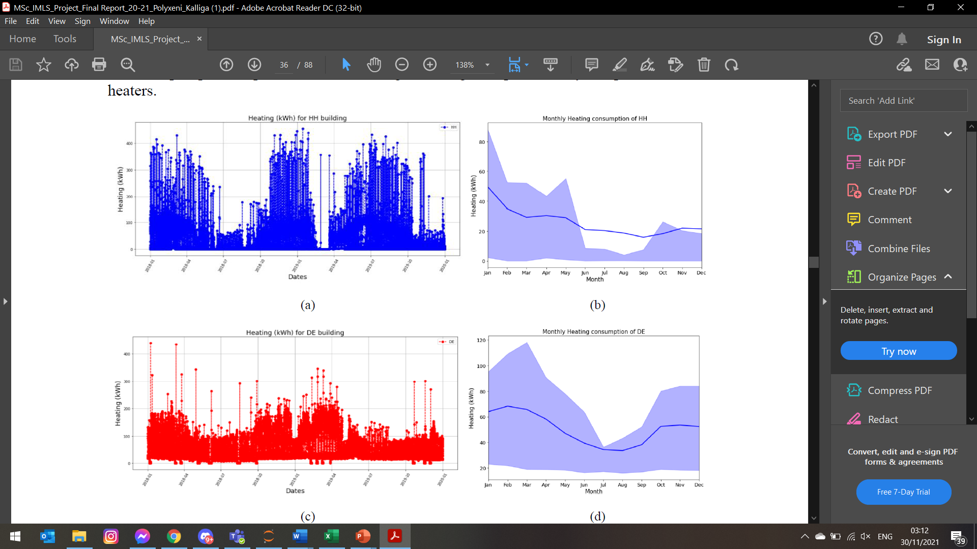

I believe that there are clear outliers in the graph?!

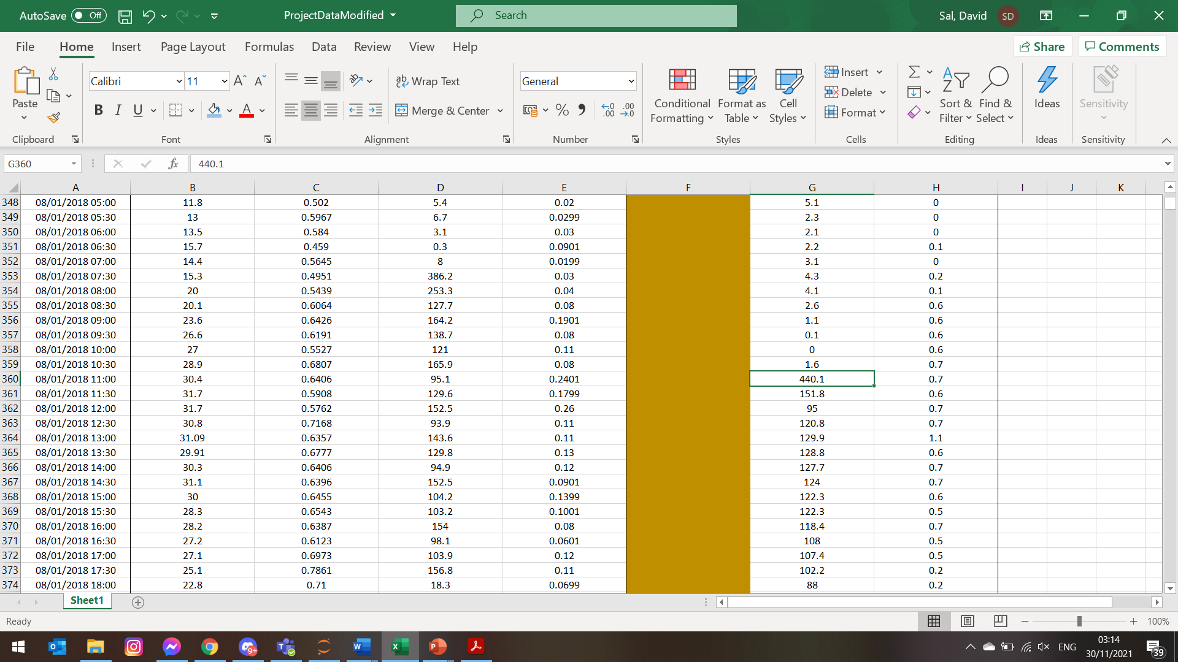

Whats that yellow marked clearly wrong part?

